Fishbone Analysis- organising a complex system so you can work on changing it

Groups can be adjusted
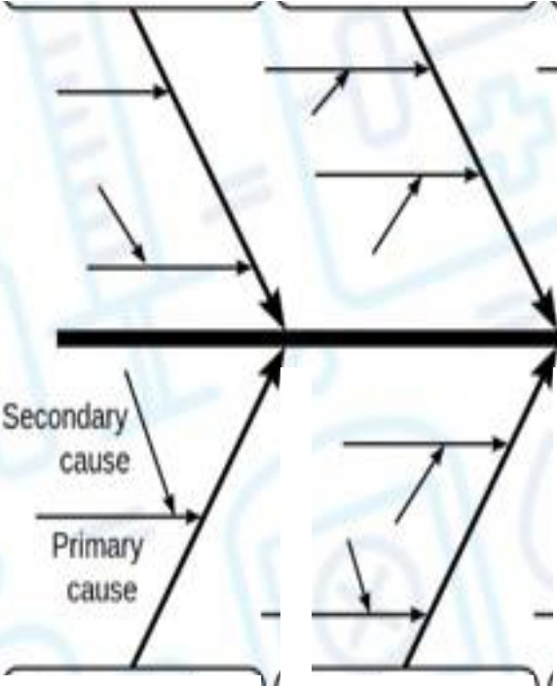
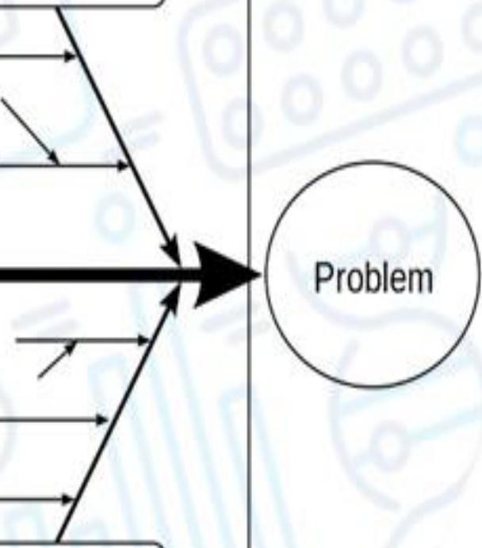cause
Equipment II Process II People

Materials II Environment II Management

The outcome of interest
Effect
- Builds a visual theory of the scope of the influencing factors
- Simulates and supports the formation of hunches about what might improve system outcomes
- Disciplines the use of categories of potential causes
- Enables discrete causes to sit in a logic framework so you don't miss critical components while working on just one of them

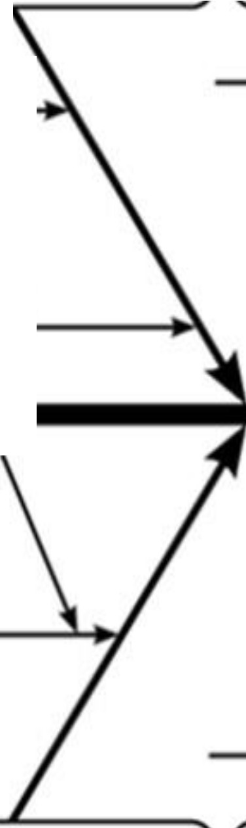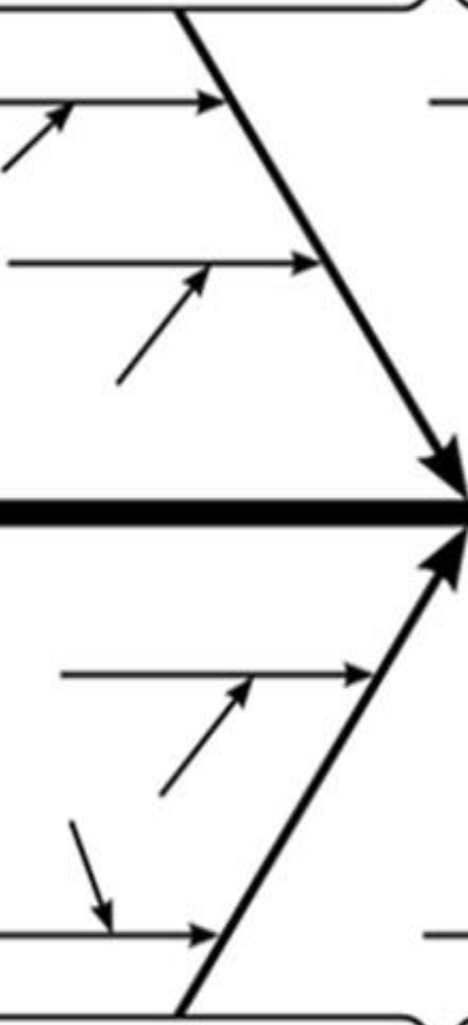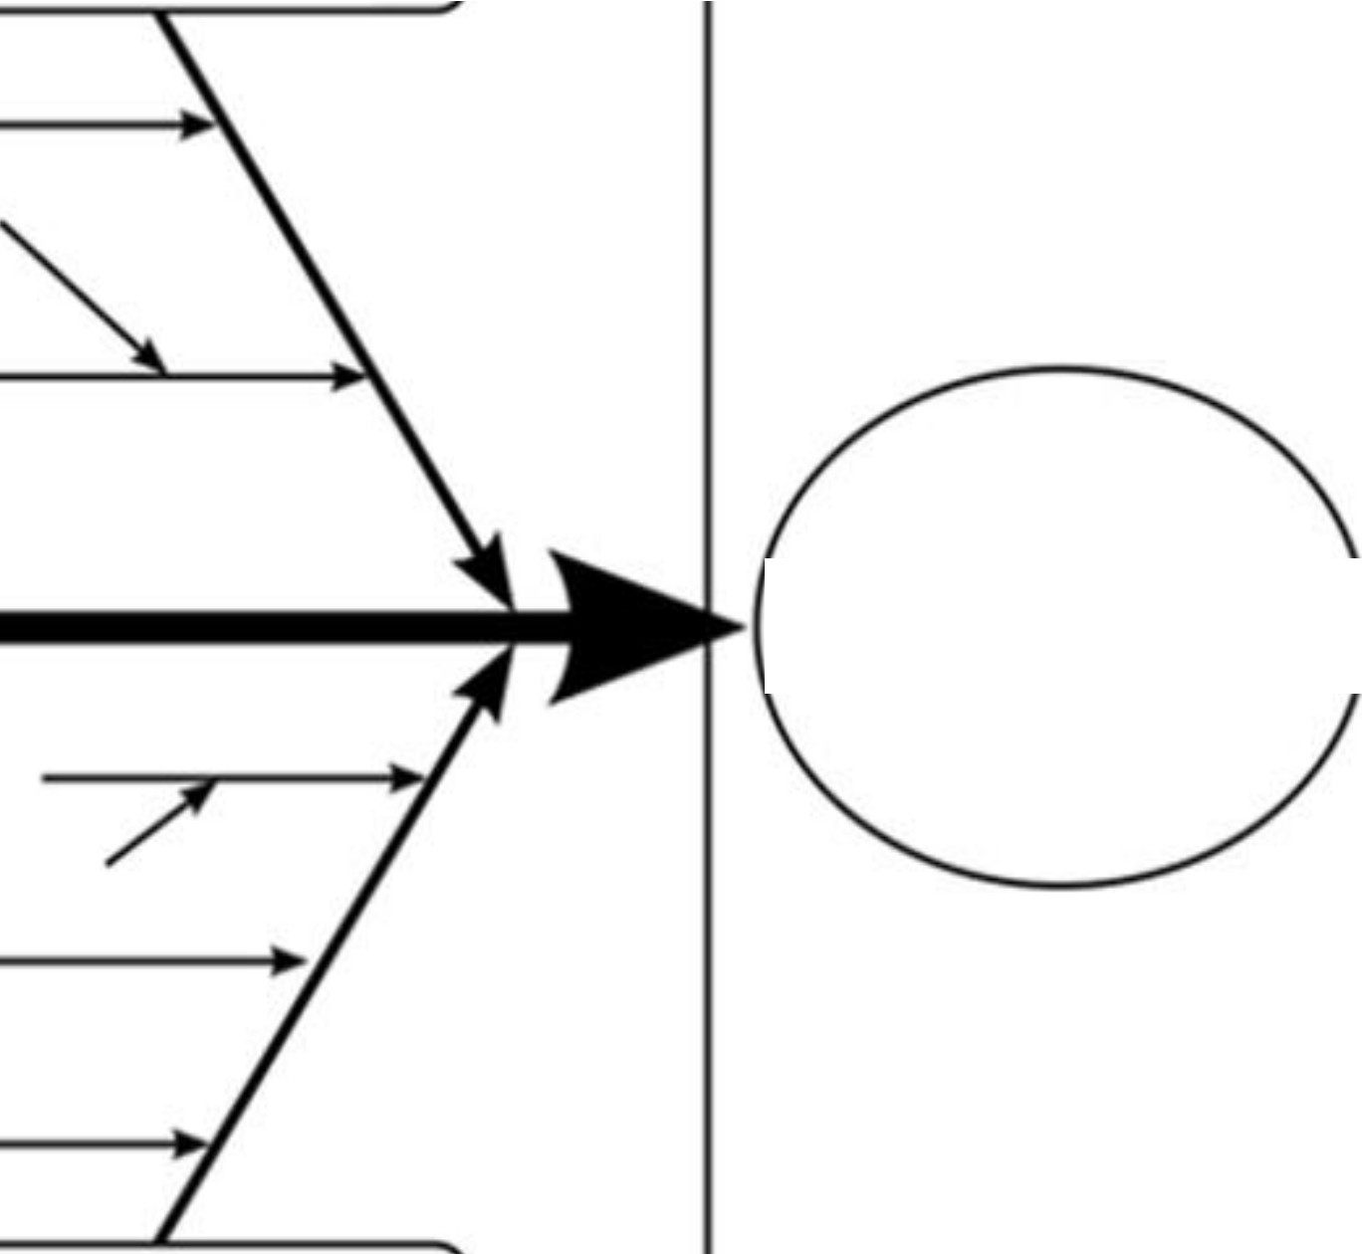OUR FISH BONE ANALYSIS

\

